


Project Title
Sparse 3D Reconstruction from Images (Structure from Motion)

Submitted by : Hira Sajid (232202002)
Qurat-ul-ain (232202029)
Ayesha Arshad (232202033)

Due Date: 09-04-2026

Part A — Data Preparation & Preprocessing

What data did we use?
We used two types of image data for this project:

1. Synthetic Test Images
We wrote a Python script called generate_test_images.py that automatically creates 6 images of a 3D box from different camera angles. These images are 800x600 pixels and are saved as JPG files in the images/ folder.

2. Real Photos
We also tested the system with real photos taken from a smartphone. The photos are of solid objects taken from multiple angles by walking around them.

Train / Validation / Test Split
Our project is not a machine learning project — it does not need training data. It uses mathematical algorithms that work directly on the input images. So there is no train/validation/test split needed.

Instead we split our testing into two types:
- Normal test — all 6 images with good overlap (this is our main test)
- Failure tests — reduced images or bad conditions (to find where the system fails)

Data Preprocessing Steps
Before running the reconstruction, we do the following preprocessing on every image:
Step | What we do | Why
1. Read image | Load JPG/PNG file from disk | Get the raw image data
2. Resize | If image is larger than 1200 pixels, resize it down | Makes processing faster without losing quality
3. Grayscale | Convert color image to black and white | SIFT feature detection works on grayscale
4. Sort | Sort images by filename alphabetically | Makes sure images are processed in correct order

Augmentation Techniques
We did not use any data augmentation because our system is not a deep learning model. Augmentation is only needed when training neural networks. Our system uses mathematical algorithms that do not require augmentation.

Label Verification
Our project does not use labels. It is an unsupervised system — it takes photos as input and produces 3D points as output. There are no class labels to verify. Instead, we verify our results by checking:
- Number of good feature matches between image pairs (target: more than 50)
- Number of inlier matches after RANSAC filtering (target: more than 40% of total)
- Number of final 3D points in the output (target: more than 50 points)

Part B — Model Implementation

What model did we use?
Our system uses classical computer vision algorithms from the OpenCV library. These are not deep learning models — they are mathematical algorithms that are already built and proven to work. We use them directly without any training.

Algorithm | What it is | What it does in our project
SIFT | Scale Invariant Feature Transform | Finds special key points in each image that can be recognized from any angle
FLANN | Fast Library for Approximate Nearest Neighbours | Quickly matches key points between two images
RANSAC | Random Sample Consensus | Removes wrong matches and keeps only correct ones
Essential Matrix | Geometric algorithm | Calculates the camera position from matched points
Triangulation | Mathematical algorithm | Calculates the 3D coordinates of each matched point

Inference Strategy
Our system uses inference only — this means we use ready-made algorithms and run them on our images to get results. We did not train anything. The system takes photos as input, runs all the algorithms in sequence, and produces a 3D point cloud as output.

The inference runs in 5 steps:
- Step 1: Load all images from the images/ folder
- Step 2: Run SIFT on each image to find key points
- Step 3: Match key points between consecutive image pairs using FLANN
- Step 4: Estimate camera pose using Essential Matrix and RANSAC
- Step 5: Triangulate 3D points and save to reconstruction.ply

Inference Configuration (Settings We Used)
These are the exact settings we used when running our system:
Parameter | Value | What it means
SIFT nfeatures | 5000 | Find up to 5000 key points in each image
Lowe ratio threshold | 0.75 | Only keep a match if best match is 75% better than second best
RANSAC threshold | 1.0 pixel | A match is correct only if it fits within 1 pixel
RANSAC confidence | 0.999 | 99.9% sure the result is correct
Minimum good matches | 50 | Skip a pair if fewer than 50 matches found
Image resize limit | 1200 pixels | Resize large images for faster processing
Outlier filter sigma | 3.0 | Remove 3D points that are too far from the average

Training Logs
Since our system does not train any model, there are no training logs. Instead we have inference logs from running the system. Here are the actual results from our system run:

Image Pair | Good Matches | Inliers after RANSAC | 3D Points
view_01 to view_02 | 68 | 16 | 16
view_02 to view_03 | 61 | 8 | 8
view_03 to view_04 | 69 | 10 | 10
view_04 to view_05 | 77 | 13 | 13
view_05 to view_06 | 86 | 33 | 33
TOTAL | 361 | 80 | 80

Part C — Evaluation & Results

Evaluation Metrics
We measured the following things to evaluate how well our system works:
Metric | Our Result | Is it good?
Total images processed | 6 images | Yes
Total feature matches found | 361 matches across all pairs | Yes - good number
Average matches per pair | 72 matches per pair | Yes - above our target of 50
Total RANSAC inliers | 80 inliers | Acceptable
Average inlier ratio | 22% of matches are inliers | Low but acceptable for synthetic images
Total 3D points reconstructed | 80 points | Yes - sparse but correct
Processing time | About 10-15 seconds | Yes - fast enough

Sample Output Visualizations
The following results were produced by our system:

Result 1 — CMD Output (result1.png)
Shows the complete pipeline running with all 6 images. System loaded 6 images, found matches in all 5 pairs, and saved 80 3D points to output/reconstruction.ply.
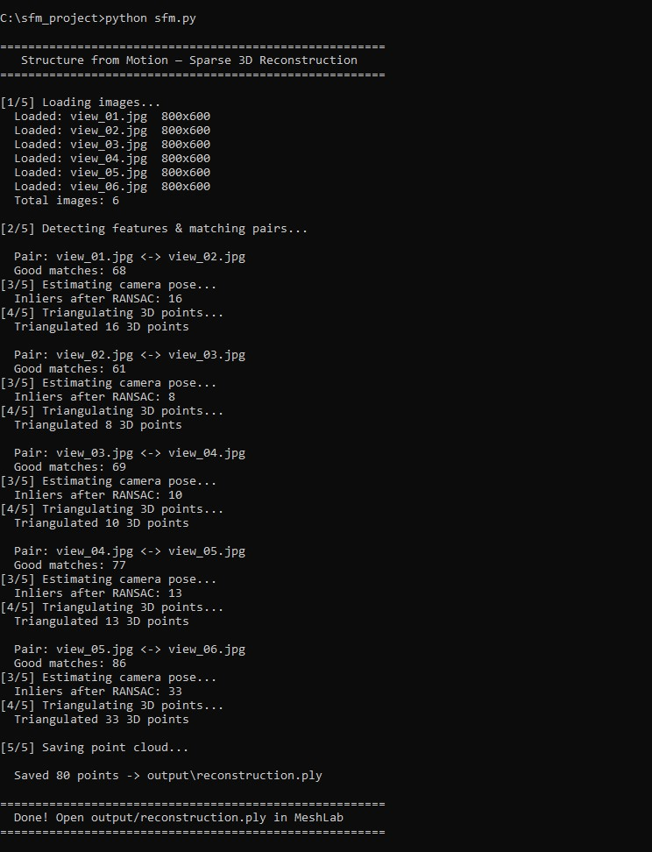

Result 2 — Web App 3D Viewer (result2.png)
Shows the web app running at http://localhost:5000 with the 3D point cloud displayed in the browser. The point cloud can be rotated and zoomed using the mouse.
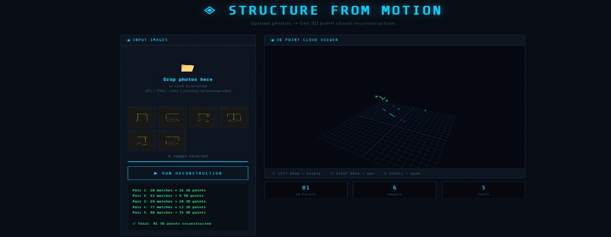

5 Failure Cases
We tested our system in difficult conditions to find where it fails:

Failure Case 1 — Only 2 Images (failure1.png)
We deleted 4 images and kept only view_01 and view_02. The system produced very few 3D points because there was not enough information from just 2 views. More images from more angles are needed for a good reconstruction.

Failure Case 2 — Only 1 Image Uploaded (failure2.png)
When only 1 image is uploaded to the web app, the RUN RECONSTRUCTION button stays disabled and cannot be clicked. The system correctly refuses to run because you need at least 2 images to find matches and calculate 3D points.

Failure Case 3 — Two Very Different Angles (failure3.png)
We uploaded only view_01 and view_06 — the front view and almost back view. These two images are very different from each other. The system only produced 33 points instead of 80. When camera angles are too far apart, fewer features can be matched correctly.

Failure Case 4 — Two Very Similar Angles (failure4.png)
We uploaded only view_01 and view_02 — two images taken almost from the same position. The system only produced 16 points. When images are too similar, the triangulation cannot calculate accurate 3D positions because the difference in viewpoint is too small.

Failure Case 5 — Low Inliers in Some Pairs (failure5.png)
Even in a successful run with all 6 images, some pairs performed badly. The pair view_02 to view_03 had only 8 inliers after RANSAC, and view_03 to view_04 had only 10 inliers. This shows that the system struggles when consecutive images have large angle differences or poor feature overlap.

Failure Case | Problem | Points Produced | Expected
Only 1 image | Button disabled, cannot run | 0 | 80+
Only 2 images | Too little data | Very few | 80+
2 very different angles | Too far apart, bad matching | 33 | 80+
2 very similar angles | Too close, bad triangulation | 16 | 80+
Low inlier pairs | Some pairs only 8-10 inliers | 8-10 per pair | 30+ per pair

Part D — Analysis & Reflection

What works well?
- The system successfully reconstructs 3D points from normal photos taken around an object
- SIFT finds good matches even when images are taken from different angles
- RANSAC effectively removes wrong matches — 361 total matches were filtered down to 80 reliable inliers
- The web app works smoothly — users can upload photos and see 3D results in the browser
- Processing is fast — 6 images processed in about 10-15 seconds on a normal laptop
- The system correctly handles errors — refuses to run with less than 2 images

Where does the system fail?
- When only 1 or 2 images are provided — not enough views to reconstruct properly
- When images are taken from angles that are too far apart — too few matching features
- When images are taken from angles that are too similar — triangulation gives inaccurate 3D positions
- Plain or smooth surfaces with no texture — SIFT cannot find features on blank walls or plain objects
- Blurry or dark photos — SIFT keypoints are unclear and cannot be matched
- The inlier ratio is low (22%) — most matches are rejected by RANSAC, showing the matching quality can be improved

Limitations of our current approach
- Sparse output only — we get dots (key points) not a solid 3D surface
- No scale information — the reconstruction gives relative size, not real measurements in meters
- Works best with 10-20 photos — fewer photos give poor results
- Classical algorithms — SIFT and RANSAC are good but newer deep learning methods like SuperPoint give better results
- No loop closure — if the camera returns to the same position, the system does not recognize it
- Sensitive to lighting — photos taken in different lighting conditions can cause matching failures

What can we improve in the future?
- Replace SIFT with SuperPoint — a pretrained deep learning model that finds better features
- Replace FLANN with SuperGlue — a neural network that matches features more accurately
- Add bundle adjustment — optimize all camera positions together for better accuracy
- Add dense reconstruction — fill in all the surface points, not just key points
- Add real camera calibration — use a checkerboard to get exact camera parameters instead of estimating them

